In this task you have to plot three diagrams in a figure.

1. The first diagram shows the binomial distribution with parameters *(n,p)* (the title is "Binomial distribution").
2. The second diagram shows the result of the simulation of this distribution (the title is "Simulated binomial distribution").  
   The simulation of this binomial distribution can be accomplished by executing *n* times an event of probability *p*. The value of the random variable is *m* if the event occurred *m* times in the *n* experiments. We repeat this *n* experiment *k* times so we get *k* values of the random variable. The *m*-th column of the second diagram should be *i/k* if the value of the random variable was *m* exactly *i* times from the *k* values.
3. The third picture shows the first *n+1* columns of the diagram of the Poisson distribution with parameter λ*=np* which approximates our binomial distribution (the title is "Approximated with Poisson-distribution"). The Poisson distribution with parameter λ is the following

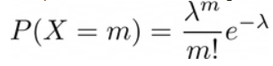

The output of this program will look like this (the scale and color is not an essential part of the figure):

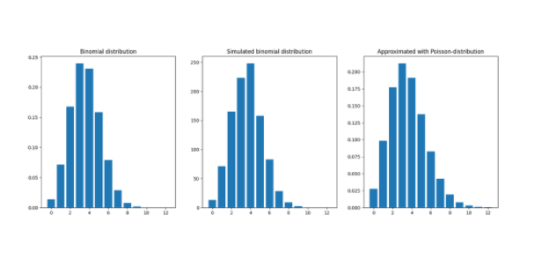

The inputs are *n, p, k*, where *n* and *p* are the parameters of the binomial distribution, and *k* is the number of simulations. The program of Adrian Smith should be run by the next command:

python3 2AAdrianSmith.py 12 0.3 1000

Do not forget to convert `sys.argv[1]`,... into numbers (`int`, `float`). Test your program with different parameters like `20 0.05 1000`, `40 0.02 1000` or `40 .5 1000`.